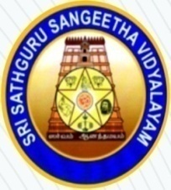
SRI SATHGURU SANGEETHA VIDYALAYAM
COLLEGE OF MUSIC & RESEARCH CENTRE
(Nationally Accredited with B+ Grade by NAAC)
(Affiliated to Tamil Nadu Music and Fine Arts University)
15-A, Gokhale Road, Tallakulam, MADURAI - 625 002
Ph. 0452-2530957; Email: sssvidyalayam@gmail.com

__________________________________________________________________________________________

